**Idea of Web Application & How It Works**

The web application serves as the primary interface for controlling the car's movement, providing a simple platform for entering key parameters such as distance, angle, and speed. Designed with accessibility and simplicity in mind, the application allows users to send commands to the ESP module, which then communicates with the Arduino to execute precise movements. The web app is accessible from any device with a browser, providing complete control. The underlying architecture integrates frontend and backend components, allowing for real-time data transmission and command execution. By abstracting the complexity of the underlying hardware, the web application allows users to focus on controlling the car's movement without requiring extensive technical knowledge.

**Data Displayed (Angle, Distance, Speed)**

The web application mainly displays the three critical parameters that govern the car's movement: angle, distance, and speed. These values are input by the user through an intuitive interface, where sliders or text fields can be used to specify precise numbers. Once set, this data is transmitted to the ESP module, which processes and relays the information to the Arduino. The application ensures that the displayed data is always accurate and up-to-date, reflecting the current state of the inputs. This functionality allows users to make quick adjustments and observe the immediate impact on the car's movement, providing a dynamic and responsive control experience.

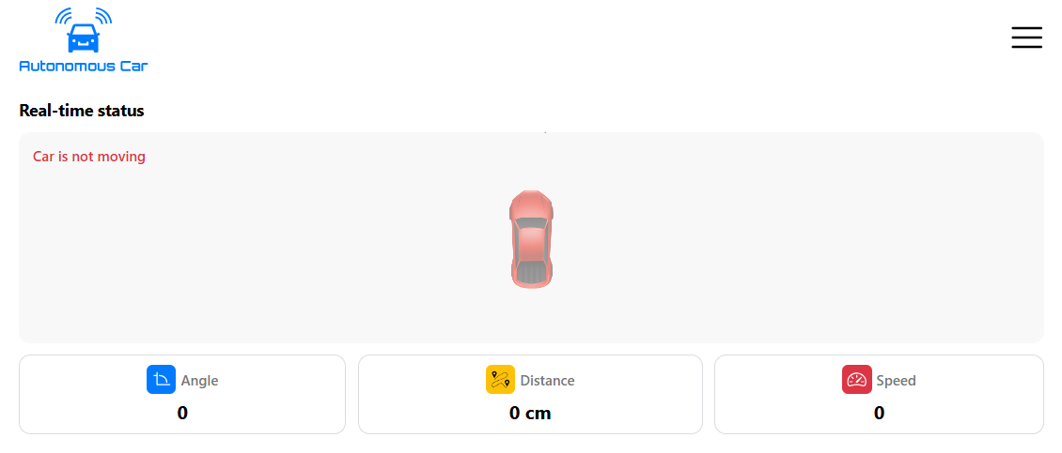

**Executed Path**

The executed path feature of the web application provides a visual representation of the path that the car will follow based on the inputted angle, distance, and speed. This path is dynamically generated and displayed on the web app, giving users a clear understanding of the car's intended movement before execution. This feature not only aids in planning and executing complex movements but also serves as a verification tool to ensure that the correct path is being followed as per the user’s commands.

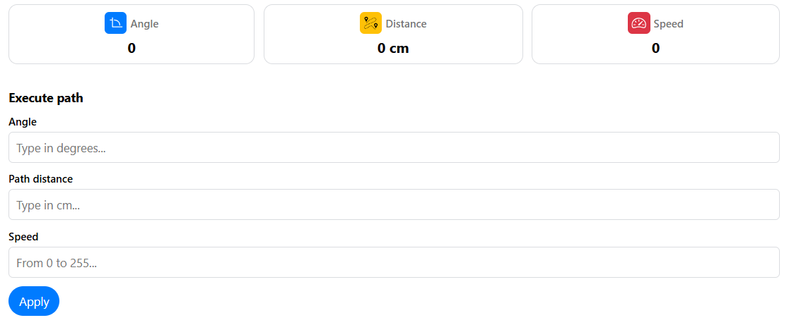

**Executed Sequence (Square, Rectangle, Triangle)**

The web application supports predefined movement sequences such as squares, rectangles, and triangles, which can be selected by the user to command the car to execute specific geometric patterns. These sequences are pre-programmed into the system and can be triggered through simple button clicks on the web interface. Once a sequence is selected, the corresponding angles and distances are automatically calculated and sent to the car for execution. This feature simplifies the process of performing complex maneuvers, as the user does not need to manually input each angle and distance. Instead, the web app handles all calculations, ensuring accurate and consistent execution of the desired shape.

